XII. INFERENCE WITH TWO CONTINUOUS VARIABLES

Scatterplots.
Correlation coefficient.
Regression equation.
Evaluating fit of the regression equation.
Comparability of correlation and regression coefficients.

Scatterplots

- Correlation and regression are used to assess the relationship between two continuous variables. One variable is defined as the dependent variable (which we denote Y), and the other is defined as the independent variable (which we denote X). Let’s start with an example. It is well known that one of the strongest predictors of sentence length is a defendant’s prior record. We collect data from a sample of 10 inmates convicted of burglary, and ask them how many months they received in their sentence (Y) and how many arrests they had prior to conviction (X). We obtain the following data.

X | Y
0 | 3
1 | 6
1 | 9
1 | 9
2 | 12
2 | 15
3 | 18
5 | 24
7 | 24
10 | 36

- One simple way to assess the relationship between two variables is to use a scatterplot, or graphical display that summarizes the nature of the association between an independent and dependent variable. The X-axis is the independent variable, and the Y-axis is the dependent variable. Each observation receives a dot at its respective X- and Y-values.
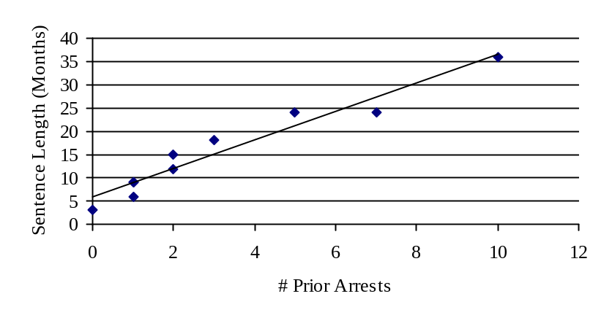
Notice that as X increases, Y also increases. We can tell with this scatterplot, without having to compute any statistics, that there is a positive relationship between prior record and sentence length. In other words, people who more prior arrests to have a longer sentence length.

- Let’s say that we also gathered data from 10 youths in juvenile detention on average school performance and the number of juvenile arrests.

X | Y
50 | 10
55 | 8
60 | 8
65 | 6
70 | 5
75 | 6
80 | 4
85 | 2
90 | 3
95 | 1
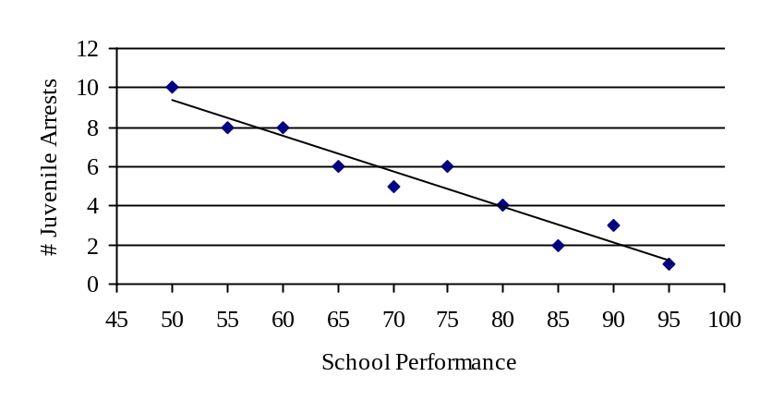
We see that as school performances increases, juvenile arrests decrease. There is thus a negative relationship between school performance and juvenile arrest. In other words, youths with high school performance tend to have a low number of arrests.

- Scatterplots thus tell us something about the direction of the association between two variables. We can add a trend line to the scatterplot to aid in the interpretation of the direction of association, or what we will refer to later as a regression line. A second piece of information that we can obtain is the amount of variation there is around the regression line, which is an indication of the strength of the association. The closer the dots are to the regression line, the stronger the association between X and Y.

- An advantage offered by scatterplot is the ability to identify outliers. The disadvantage of using a scatterplot to summarize the relationship between two variables is that it is not very precise. We can only determine that prior record and sentence length are positively related, and we can only “eyeball” the regression line. Our ultimate goal is to be a little more exact in describing the nature of the relationship between X and Y. There are two coefficients that we can compute to be more precise: a correlation coefficient or regression equation.

Correlation Coefficient

- A correlation “standardizes” the association between two variables. We need to calculate the variance of X, the variance of Y, and the crossproduct (or covariance) of X and Y.

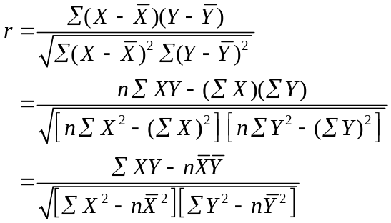

- Let’s compute the correlation between prior record and sentence length.

X | Y | XY | X ² | Y ²
0 | 3 | 0 | 0 | 9
1 | 6 | 6 | 1 | 36
1 | 9 | 9 | 1 | 81
1 | 9 | 9 | 1 | 81
2 | 12 | 24 | 4 | 144
2 | 15 | 30 | 4 | 225
3 | 18 | 54 | 9 | 324
5 | 24 | 120 | 25 | 576
7 | 24 | 168 | 49 | 576
10 | 36 | 360 | 100 | 1296
32 | 156 | 780 | 194 | 3348
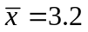 | 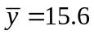

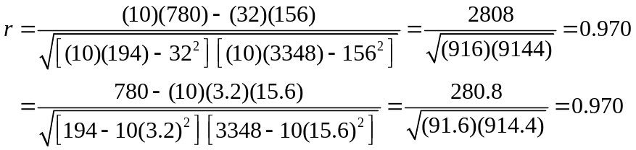

- We can easily tell that prior record is positively related to sentence length, and that it is a very strong association. Let’s do the same with school performance and juvenile arrest.

X | Y | XY | X ² | Y ²
50 | 10 | 500 | 2500 | 100
55 | 8 | 440 | 3025 | 64
60 | 8 | 480 | 3600 | 64
65 | 6 | 390 | 4225 | 36
70 | 5 | 350 | 4900 | 25
75 | 6 | 450 | 5625 | 36
80 | 4 | 320 | 6400 | 16
85 | 2 | 170 | 7225 | 4
90 | 3 | 270 | 8100 | 9
95 | 1 | 95 | 9025 | 1
725 | 53 | 3465 | 54625 | 355
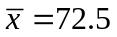 | 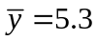

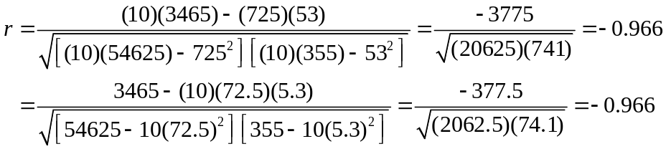

- The association between age and sentence length is thus positive and very strong. One nice thing about correlation coefficients is that they can be directly compared. Another useful property of the correlation coefficient is that when we square it, we can use an “explained variance” interpretation. So, prior record explains 0.970² = 0.941 → 94.1% of the variance in sentence length. School performance explains –0.966² = 0.933 → 93.3% of the variance in juvenile arrest.

- How about if we want to conduct a hypothesis test? We want to know if a linear relationship exists between prior record and sentence length in the population, or if our estimate of the correlation is the result of sampling error. Let’s go through the five steps.

  - Step 1: State hypotheses. Our research hypothesis is this: Does having a prior record increase sentence length? The population parameter we are trying to estimate is ρ, the population correlation coefficient, and its sample analog is r. The null and alternative hypotheses are H₀: ρ = 0 and H₁: ρ > 0.

  - Step 2: Obtain a probability distribution. The probability distribution for correlation coefficients is the t-distribution, with df = n – 2 = 8.

  - Step 3: Make decision rules. Let’s use α = .05. We will reject the null hypothesis if TS > 1.860.

  - Step 4: Calculate the test statistic. The test statistic for a correlation is

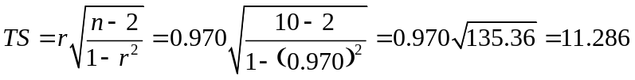

  - Step 5: Make a decision about the null hypothesis. We reject the null hypothesis, and conclude that having a prior record significantly increases sentence length.

- Let’s do a hypothesis test for the correlation between school performance and juvenile arrest. The research question is: Is school performance related to juvenile arrest?

1) H₁: ρ ≠ 0, H₀: ρ = 0
2) t-distribution, df = n – 2 = 8
3) α = .01 (two-tailed), t_{crit} = 3.355, reject H₀ if |TS| > 3.355
4) 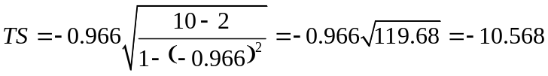
5) Reject H₀, school performance is significantly related to juvenile arrest

Regression Equation

- Another way to assess the relationship between two continuous variables is by estimating a regression equation. When a scatterplot indicates that two variables are more or less linearly related, it is convenient to draw a straight line through the middle of the data points. When we estimate the regression line (as opposed to trying to eyeball it), it can be shown that it is the “best-fitting” line, which means that the line falls as close to every data point as possible.

- A regression equation in the population is of the form

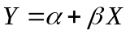

In this equation, α and β are the population parameters that summarize the association between X and Y. A regression equation using sample data to estimate these parameters is of the form

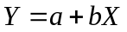

In this equation, a is the y-intercept (or constant), and b is the slope. Once these two parameters are estimated, we can substitute any value for X to determine the “best guess” of Y for that particular value of X. The estimate b tells us the effect on Y of a one-unit increase in X. It is calculated by the formula

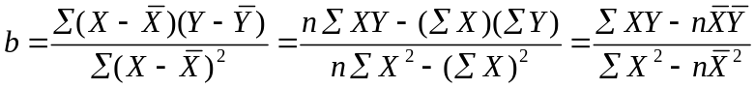

The y-intercept, a, is very simply the value of Y when X = 0. The purpose of the intercept is to “anchor” the regression line to the y-axis. It simply tells us the point at which the regression line crosses the y-axis. Once we know b, we can solve for the intercept by

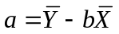

- Let’s estimate the regression equation for our prior record and sentence length example.

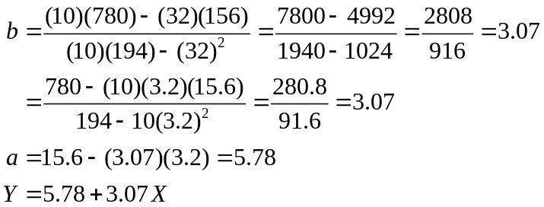

The value for b means that an increase of one prior arrest produces 3.07 additional months in sentence length.

- This regression equation comes in handy when we want to calculate predicted values of Y for given values of X. Let’s pick a few values of X to illustrate.

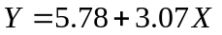
X | Y
0 | 5.8
2 | 11.9
4 | 18.1
6 | 24.2
8 | 30.3
10 | 36.5

- Now let’s estimate the regression equation for the school performance and juvenile arrest example.

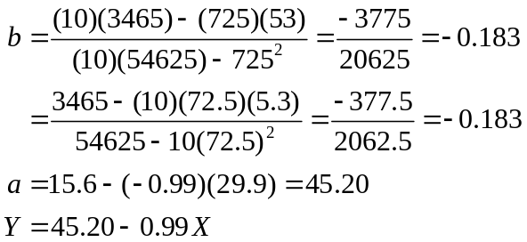

- We can also do a hypothesis test for the significance of the regression coefficient, b. To conduct this hypothesis test, we need to estimate a term known as the standard error of the slope.

Comparability of Correlation and Regression Coefficients

- You can see by the formula that correlation and regression coefficients are intimately related. In fact, the following equalities hold true

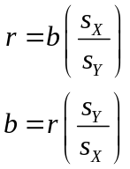

- Given their similarity, what does regression add to correlation? Let’s use the prior record and sentence length example to illustrate. Consider the case where we have no information other than a person’s sentence length. Our “best guess” for any particular individual, absent any further information, is the mean sentence length for the sample, 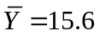. Once we include an additional variable, X (number of prior arrests), we can incorporate the extra information that this variable contributes by estimating a regression line and predicting the value of Y that lies at any point on the line. So, whenever two variables are significantly correlated, we can make better predictions about Y when we take into account the value of X than if we simply calculated the mean of Y.

